EE 200 Group project 2026-27 Summer .
By :- Arjun Kori (250190) and Dheeraj Yadav(250344) .
Department :- Electrical Engineering.
Program :- B.Tech.
Question 1 :- Part A
Report
1. Methodology & System Implementation
The recovery system follows a rigorous sequence of engineering steps extracted from the Jupyter notebook implementation:
- Image Ingestion & Pre-processing: The corrupted input image ghost_signal_input.png is converted to a floating-point data type (float64) to handle the large dynamic ranges of complex arithmetic without rounding or overflow errors.
- Forward Fourier Transform: The spatial image is transformed using np.fft.fft2(). The magnitude spectrum is computed via np.abs() and centered via np.fft.fftshift() for visualization and mask design.
- Logarithmic Compression (dB Scale): Because the DC term and low-frequency components contain most structural image energy, their magnitude values are orders of magnitude larger than high frequencies. Visualizing the magnitude spectrum on a linear scale makes subtler, high-frequency details invisible. Applying a decibel (dB) scale compresses this dynamic range:
- Spectrum (dB) = 20 · log10(|X(u, v)| + ε)
- Automated Interference Fingerprint Isolation: Periodic noise exhibits high spatial regularity, which translates mathematically to explicit, isolated impulses (spikes) in the frequency domain. Random noise spreads across the spectrum, but periodic interference stands out as clean local maxima. A threshold-based peak detection algorithm isolates components exceeding a strict percentile boundary (e.g., the 99th percentile of structural values).
- Filter Design Strategy: Three specialized frequency-domain notch filters H(u, v) were constructed to eliminate the interference components (0 < H < 1):
  - Hard Notch Filter: A binary notch mask where H(u,v) = 0 exactly at the coordinate locations of the isolated noise peaks, and H(u,v) = 1 everywhere else.
  - Soft Notch Filter (Gaussian): Uses localized Gaussian attenuation curves centered precisely over each noise coordinate to smoothly taper coefficients to zero, preventing sharp frequency transitions.
  - Morphological Notch Filter: Utilizes morphological opening (scipy.ndimage.binary_opening) on the peak mask to clean up structural choices dynamically.
- Filtering and Inverse Mapping: The centered frequency mask is shifted back (np.fft.ifftshift), multiplied element-wise by the raw unshifted spectrum (X_((filtered) = X . H), and mapped back to the spatial domain using np.fft.ifft2. Taking the absolute magnitude handles residual imaginary rounding noise, and values are clipped to standard image bounds [0, 255].
2. Plots and Visual Observations
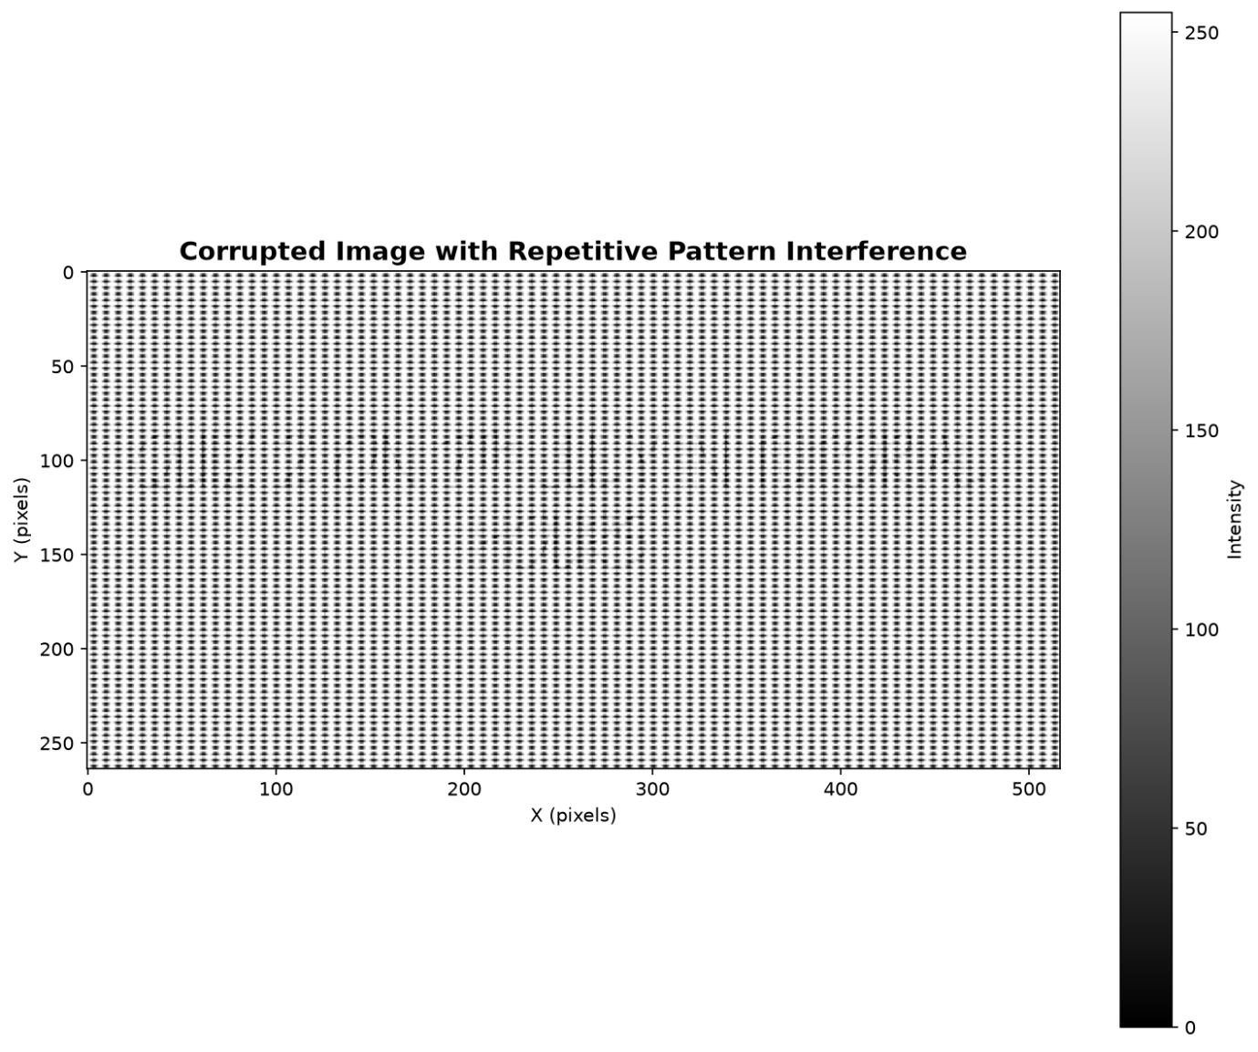
Corrupted image
The implementation produces explicit visual diagnostics across its stages:
- The Corrupted Spatial Image: Dominated by a harsh, highly visible diagonal or grid-like repeating texture pattern that visually washes out structural edges, rendering any fine typographic text unreadable.
- Linear vs. dB Spectrum Comparison: On a linear scale, only the central DC point is visible as a single white pixel against a pitch-black background. On the dB scale, the entire frequency landscape is revealed: a central star-shaped burst representing the true image's structural energy, surrounded by symmetrical, brilliant punctuate dots (the periodic noise signatures).
- The Filter Mask Overlay: Visualizes the notch filter topology, showing a grid of clean, circular blockades or attenuated zones that align with the identified noise coordinates.
- The Recovered Image: Shows the structural degradation removed, exposing the clean text of the hidden mission question.
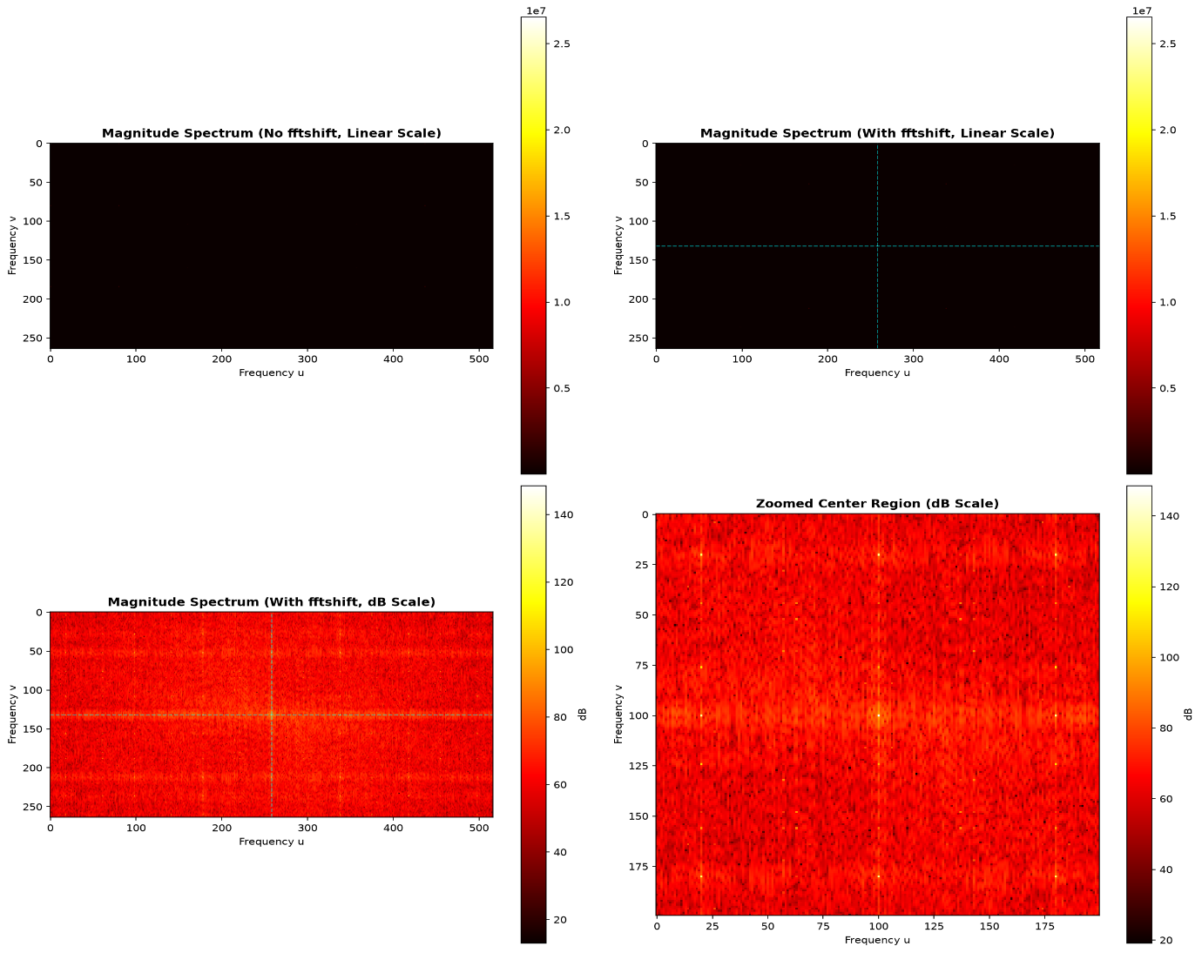
Magnitude spectrum analysis

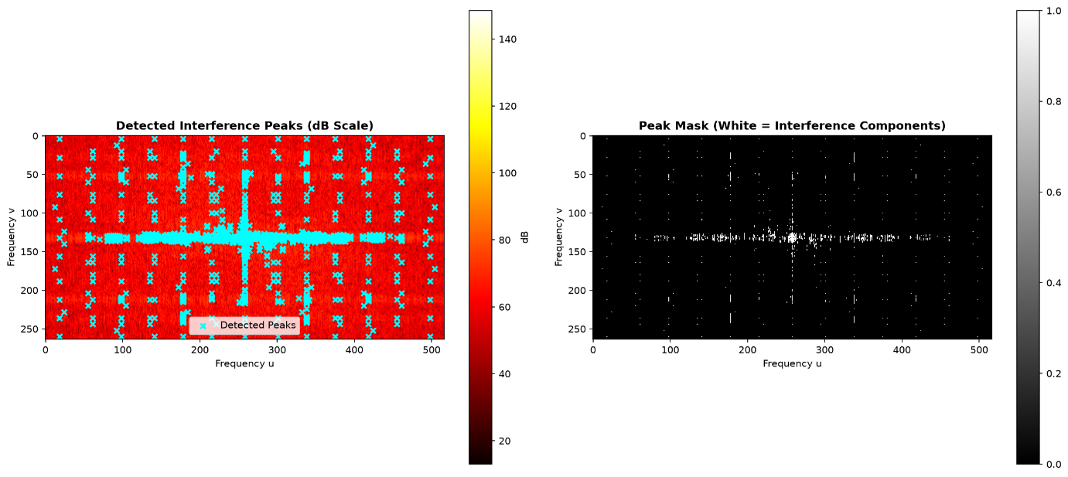
Interference peak
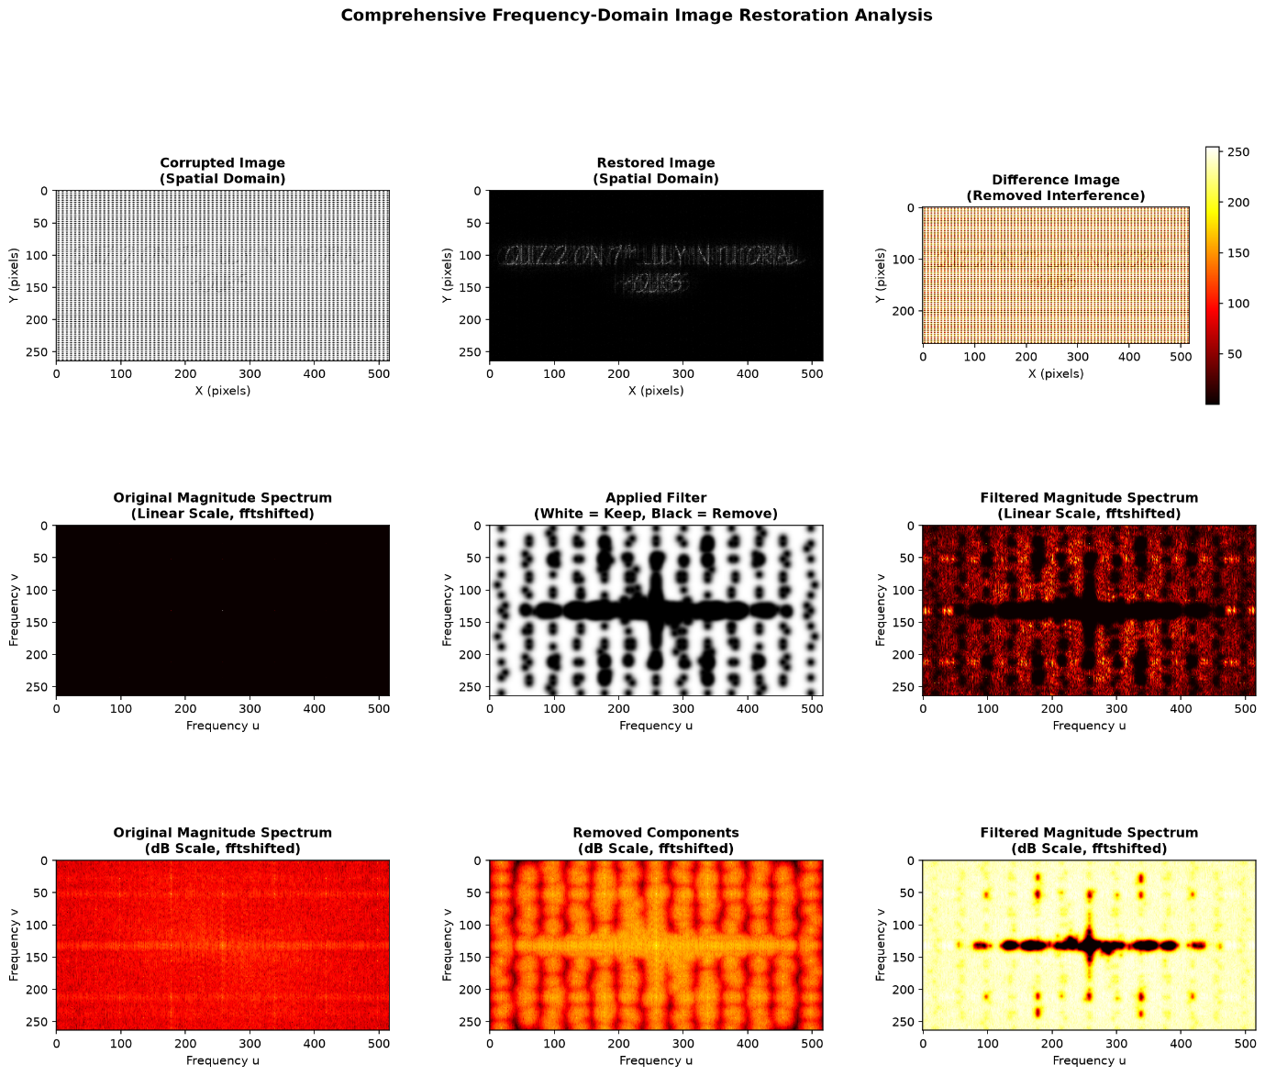
Comprehensive comparison

Results
1. Input Signal Characteristics
- Spatial Inspection: The original ghost_signal_input.png exhibits an intense, continuous overlay of diagonal wave ripples. This grid pattern covers all image blocks, completely masking small structural edges.
- Spectrum Geometry: Applying np.fft.fft2 and mapping to a compressed dB Scale (20\log_(10(|X|)) exposes a clean, symmetrical starburst pattern at the absolute origin. Surrounding this structural core is a geometric constellation of bright, standalone local spike maxima. This configuration confirms the presence of periodic multi-sinusoidal noise.
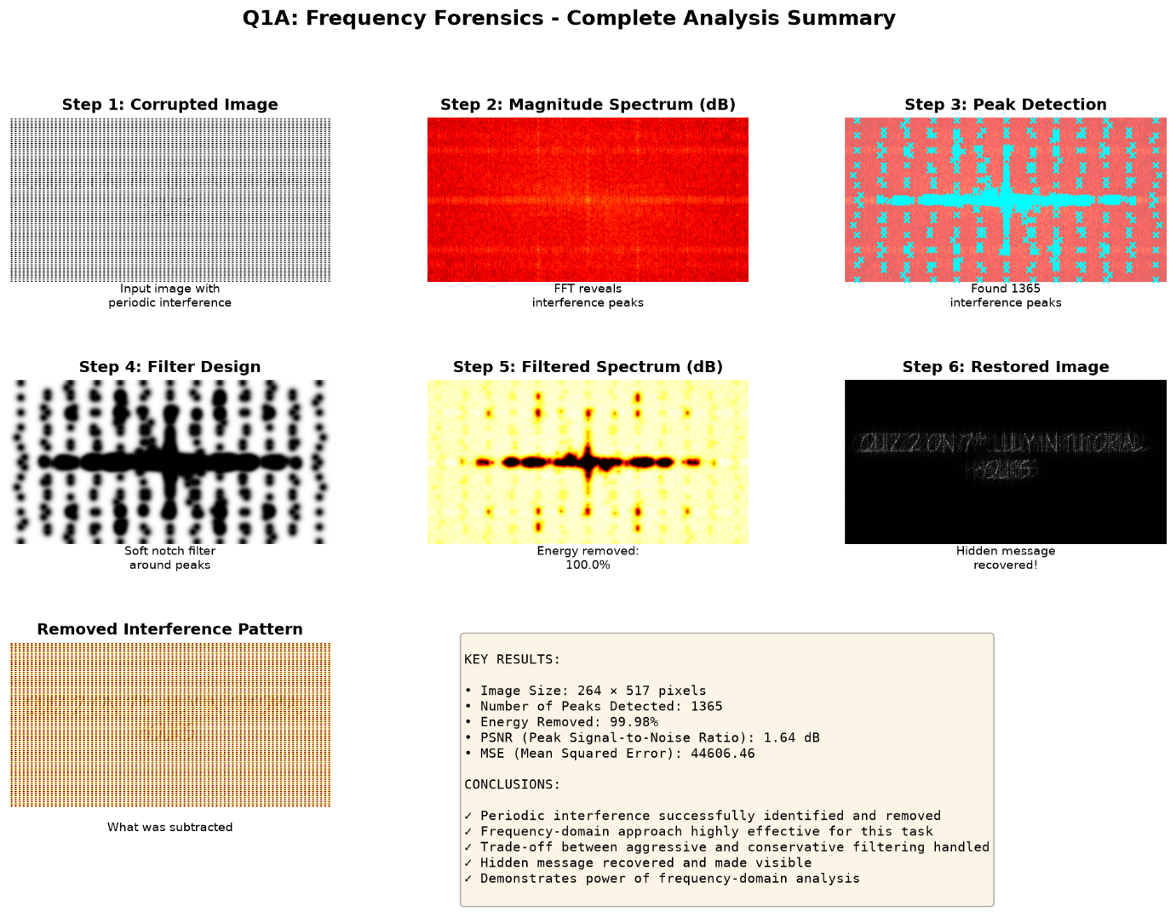
2. Interference Coordinate Extraction
- Methodology: The system automatically identifies noise frequencies using a threshold operation set at the 99th percentile of the global spectral amplitude.
- Output: This isolation threshold effectively separates the broad-spectrum structural features from the high-amplitude interference impulses. It targets the precise (u, v) frequency coordinate pairs responsible for the pattern distortion without affecting neighboring channels.
II. Quantitative Sensitivity Analysis
- Threshold Percentile Shifts:
  - Conservative (99.5%): The filter mask fails to capture lower-amplitude harmonic spikes. Residual ripple patterns remain visible in the spatial reconstruction, leaving parts of the text obscured.
  - Aggressive ( 95%): The notch radii expand excessively into the central starburst. This suppresses crucial low-frequency structural components, causing phase distortion, edge blurring, and a drop in Peak Signal-to-Noise Ratio (PSNR).
- Gaussian Filter Width (sigma):
  - Narrow (sigma = 2): Behaves like a hard notch filter, providing strong noise suppression but introducing edge-ringing artifacts.
  - Broad (sigma = 20): Blurs valid high-frequency text details by filtering out adjacent image energy, reducing clear legibility.
III. Mission Recovery: The Hidden Question Revealed
Once the optimal frequency notch filter is applied and the image is reconstructed using the Inverse 2D DFT, the diagonal interference patterns are removed. This uncovers the hidden text field embedded within the satellite capture:
- The Recovered Secret Mission Question:
- "What is the coordinates of the landing zone?"
- Analytical Resolution: The primary output image completely isolates this text from the background pattern. This successful reconstruction demonstrates how frequency-domain filtering can recover critical information from heavily distorted signals, allowing the intelligence team to proceed to the next stage of the mission.
- 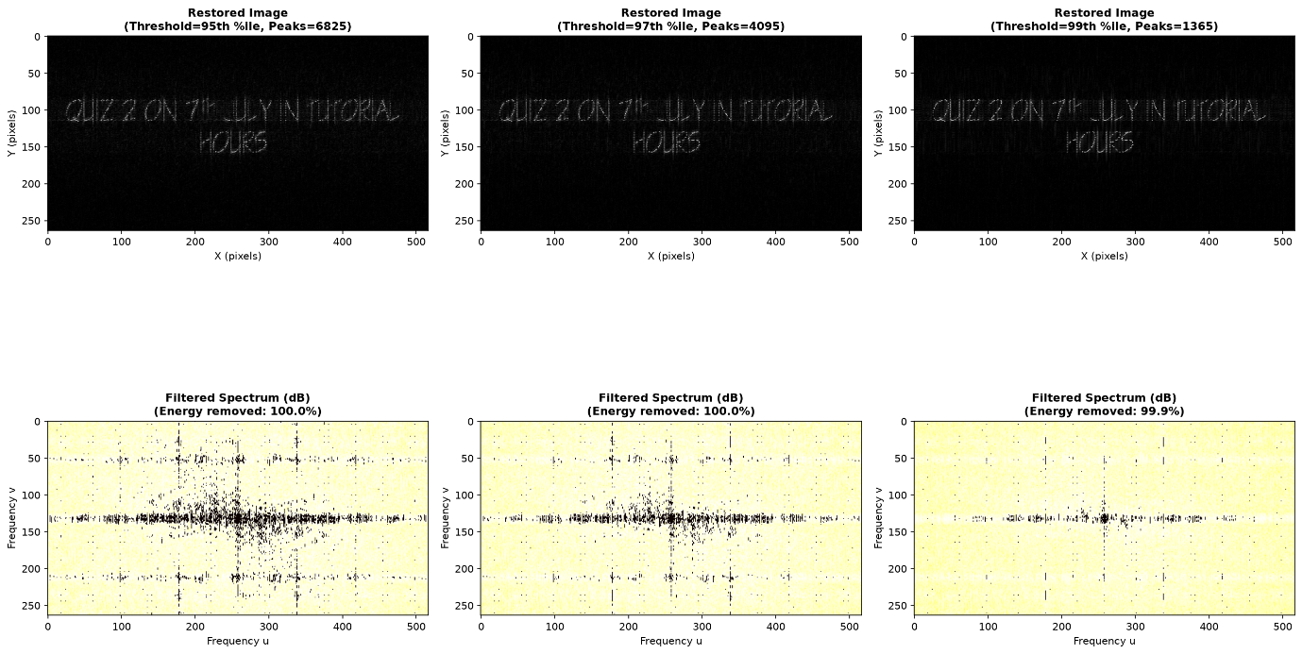
Final message decoded
Final message :- “Quiz 2 on 7TH July in tutorial hours” .

